**Abstract**

Our tool provides an intuitive workflow that imports and processes raw unfiltered shape memory alloy mechanical (tensile/compression), thermal (DSC), or thermomechanical (tensile/compression with environmental chamber) data to produce customizable figures and systematically derived material data. This toolset can extract data from multiple inputs such as tensile test data and external thermocouples and automatically synchronize them onto the same time series. With raw force and displacement data, the SMA REACT can calculate strains and stresses based on various sample geometries. Coupling temperature, stress, and strain data, this tool can apply customizable filters and remove systematic errors within the dataset, periodically prompting the user for filter approval. The refined data is then iteratively calibrated to best fit a Lagoudas-Hartl constitutive model. The program is open-source allowing for other features and SMA models to be added. The focus on automated and intuitive generation of figures and model fitting greatly assist experimentalists, modelers, and designers to iterate on novel shape memory alloy materials and applications.

**Introduction**

Shape memory alloy actuators have found uses in the fields of aerospace, biomedical, civil, robotics, and more by virtue of their high actuation energy density and solid-state operation [1]. The inherent complexity of SMAs is an opportunity for more space- and weight-efficient assemblies, but a challenge from a design perspective. A notional process for developing a shape memory alloy engineering system could be divided into six stages (detailed graphically in Fig. 1). Step 1 requires identifying one’s system requirements which entails discerning a suitable range of material requirements (i.e., stiffness, actuation strain, transformation temperatures). These material requirements directly drive step 2, i.e., choosing the precise SMA composition. Finding relations between composition and material properties have recently been streamlined with NASA’s SMA database tool [2], [3].

The arduous journey of turning a material concept into a reality involves the many iterations between Steps 3-5, i.e., processing, characterization, and model fitting. Processing differences during manufacturing can affect the material properties, such as reducing an ingot into a wire or tuning print parameters for additively manufactured SMAs [4]. Characterization enables the simultaneous assessment of the new processing techniques and responses to loading conditions (i.e., tension, compression, or torsion). Rigorous engineers may seek to validate the behavior of a new material within the original system requirements. This can be done by fitting the characterization data to a model that captures the full thermomechanical constitutive response (i.e., the relationship between temperature, stress, and strain). With a calibrated constitutive model (such as the Lagoudas [5] or Brinson [6] models) engineers can design the system to confirm the behavior of the unique nonlinearities inherent of SMAs. Iteration of these steps will likely occur multiple times to reach requirements. Once the constitutive model accurately represents the SMA behavior and the material satisfies requirements, the SMA device can then be integrated into the engineering system.

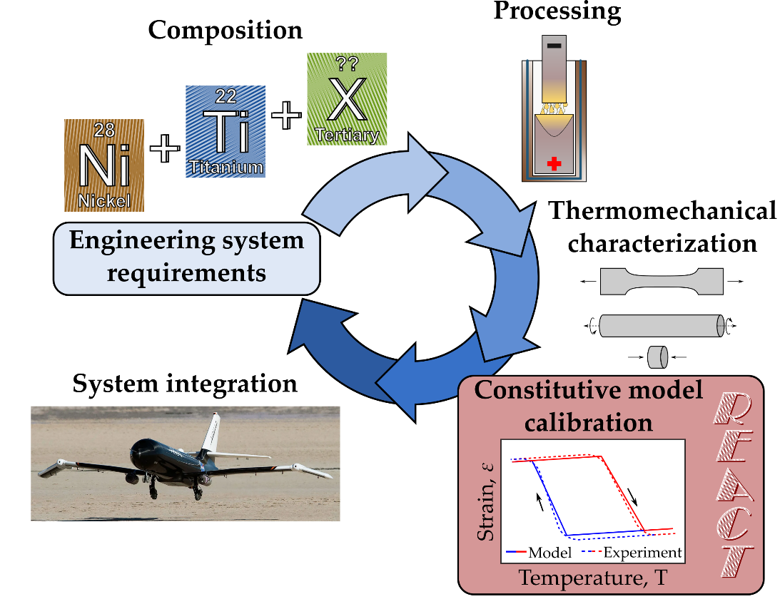

Figure : The typical SMA development process involves many discrete steps. This work provides an easy constitutive model calibration tool, the Rendering of Experimental Analysis and Calibration Tool, to enable SMA component design.

Such design processes involve many disciplines and can be a daunting endeavor for small teams or new adopters of SMA technology. Characterization hardware is complex; due to the various external state variables that govern shape memory material behavior, extracting a stress-strain-temperature history often requires synchronization of multiple metrologies (i.e., thermocouples, load cells, and strain gauges). Development requires significant time and effort, but the greater SMA community has developed tools to expedite certain stages.

The composition-processing-property space for SMAs is becoming well understood, and many recently developed tools enable quick discovery of new alloys [nasa][7], [8], [9]. ASMADA, the Automatic Shape Memory Alloy Data Analyzer, identifies heating and cooling cycles of SMAs and extracts SMA material properties according to ASTM standard E097 [10], [11], [12]. The Shape Memory Materials Analysis and Research Tool (SM2ART), also known as SMAnalytics, provides an extensive open-source database of tested shape memory alloys and their standard properties [2], [3]. Many research groups have published user material models (i.e., UMATs) to interface with open-source and commercial finite element solvers [13], [14], [15], [16]. [20]-focused

In this work, we detail a streamlined open-source, GUI-based tool to help both material scientists and design engineers analyze their thermomechanical data and calibrate an appropriate SMA constitutive model. We deem this tool REACT, for the Rendering of Experimental Analysis and Calibration Tool. REACT provides an intuitive workflow that imports and processes raw unfiltered shape memory alloy mechanical (tensile/compression), thermal (DSC), or thermomechanical (tensile/compression with environmental chamber) data to produce customizable figures and systematically derived constitutive models (depicted schematically in Figure 2). For iterative calibration, REACT allows the user to choose bounds and lock-in values to further increase speed and accessibility. The tool is written in python but requires no programming experience to use; it is available on GitHub under the GNU General Public License [x]. Two modules accomplish the essential tasks of data processing and constitutive model calibration.

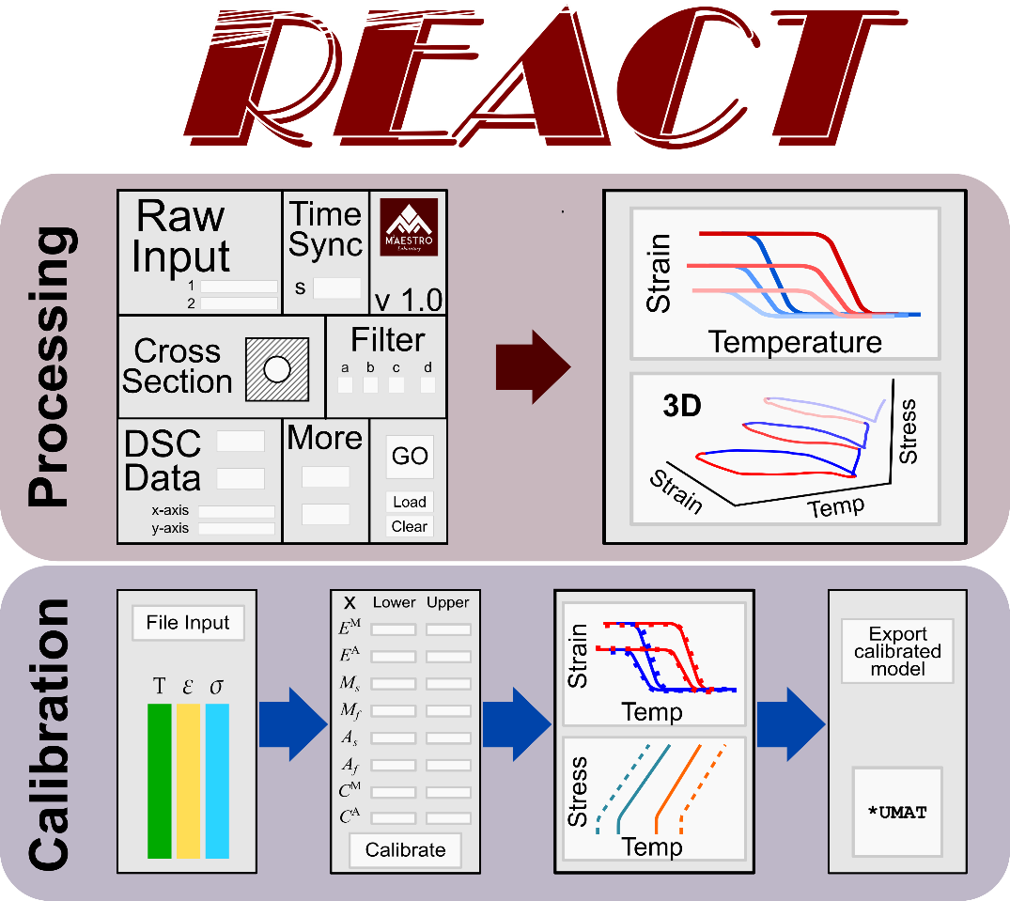

Figure : SMA-REACT allows the user to load their own data, specify known model parameters, and find an optimal calibration that best approximates experimental response.

**Method description**

(Add some meta-text of what this section is, and why it’s different than documentation). Full code documentation of the processing module can be found online [link to your cool wiki].

**Data Processing Module**

Shape memory alloy characterization requires acquisition of at least stress, strain, and temperature histories. Sometimes these histories rely on different telemetries and must be synchronized into a single data file. The SMA REACT processing module extracts data from multiple inputs such as a load frame and external thermocouples and automatically synchronizes them onto the same time series. With unfiltered force and displacement data, REACT can calculate strains and stresses based on various sample geometries. Coupling temperature, stress, and strain data, this tool can apply customizable filters and remove systematic errors within the dataset. The program then produces various figures to help visualize the complex shape memory alloy material behavior. Users can export this processed data to the next module of the tool, Model Calibration.

**Model Calibration Module**

For many applications, selecting a particular SMA component based on transformation temperature and maximum transformation strain is insufficient; the transformation temperatures and actuation strain in the *operating stress regime* must be well characterized and predictable. this intended

A deterministic amount of data can allow for derived closed-form analytical expressions for simple models [17], [18]. However, when the operating stress regime of the SMA spans many stress regions and requires multiple (> 3) experimental tests, these analytical methods become overdetermined. Numerical optimization must be employed to find the combination of model parameters that best fit experimental data, demonstrated within [19], [21], [22], [23]. These approaches help to speed the process, but exist as purpose-built codes and are have limited applicability outside the authors’ specific application or research group.

Given filtered and synchronized experimental data from the processing module, the model calibration module finds the best fit of constitutive model parameters (martensitic elastic modulus, austenite start temperature, etc.) based on the Lagoudas one-dimensional constitutive model. The developed calibration routine leverages hybrid optimization to minimize error between model prediction and experimental data. Hybrid optimization comprises a global optimization (i.e., a genetic algorithm) to identify a starting point for a local gradient-based optimization (i.e., SLSQP). Our tool enables the user to customize the optimization routine as well as the model parameters to be optimized (e.g., bounds and free variables). Outputs from the calibration routine include a set of model parameters to be used in future analyses (i.e., material properties for FEA) and a thermodynamically consistent phase diagram based on calibrated model parameters.

Our tool leverages the genetic algorithm NSGA-II [24], [25] for the global search and then SLSQP implemented in SciPy [26] for the local search, although the tool is modular and can be modified to use other optimization algorithms. For all example calibrations in this text, we specify the population size and number of generations to be 100 and at least 10, respectively for NSGA-II. We restrict SLSQP to 100 maximum iterations. Though REACT calibrates for only one SMA model at the moment, the developed framework in REACT can be expanded to consider other constitutive models, higher dimensional models (e.g., 3D models with anisotropic effects), and different loading modes (e.g., superelasticity).

**The One-dimensional Lagoudas SMA Constitutive Model: A brief primer**

The Lagoudas shape memory alloy constitutive model uses the Gibbs' free energy to derive a thermodynamically consistent relationship between stress and strain. In this work, we leverage the temperature- and strain-driven implementation of this model for wider applicability in standard finite element suites. In this section, we will omit a full model derivation (see Lagoudas et al. [5] for more information) , but rather highlight the seventeen unique but dependent model parameters that need calibrated and their effects on constitutive behavior.

Table :The one-dimensional reduction of the Lagoudas SMA constitutive model requires calibration of 17 unique but dependent parameters.

|  |  |  |
| --- | --- | --- |
| **Parameter** | **Mathematical Symbol** | **Units (SI)** |
| **Thermoelastic properties** |  |  |
| Elastic moduli |  | Pa |
| Coefficient of thermal expansion |  | 1/K |
| **Transformation properties** |  |  |
| Transformation temperatures (at zero-stress) |  | K |
| Stress-influence coefficients |  | Pa/K |
| **Transformation strain properties** |  |  |
| Minimum transformation strain |  | mm/mm |
| Maximum transformation strain |  | mm/mm |
| Critical stress at which transformation strain manifests |  | Pa |
| Transformation strain rise time |  | 1/Pa |
| **Smooth hardening properties** |  |  |
| Smooth hardening coefficients |  | - |

The Lagoudas one-dimensional constitutive model comprises four interdependent parameter groups.

1. **Thermoelastic properties** include the elastic moduli for each material phase ( and for austenite and martensite, respectively) and the coefficient of thermal expansion . Note this model formulation assumes the coefficient of thermal expansion is constant with respect to material phase; this allows the use of simpler nonlinear solution methods (i.e., Convex Cutting Plane [27]).
2. **Transformation properties** include zero-stress transformation temperatures and stress-influence coefficients . Zero-stress transformation temperatures define the start and end of transformation at zero stress (denoted by the character for the material phase and the subscript for the start and end). Stress-influence coefficients define how transformation temperatures change with respect to stress and are assumed to be constant with respect to material phase; the slope of the stress-temperature phase diagram at the *calibration stress[1]* gives these two values.
3. **Transformation strain properties** define the evolution of transformation strain with respect to stress and are crucial to understand if the material exhibits sufficient transformation strain at the design stress. The transformation strain is approximated as an asymptotic exponential function, where and are the minimum and maximum transformation strain, defines the critical stress at which transformation strain manifests, and is the *rise time*, or how quickly the transformation strain increases from to .
4. **Smooth hardening properties** define the smoothness of the transition between elastic response and transformation, or vice versa. They are numerical values bounded between 0 and 1 and are ordered from one to four, corresponding to a hot-to-cold actuation loop (i.e., ).

As mentioned earlier, the seventeen material properties that define shape memory alloy constitutive response are unique but interdependent. For example, a change in smooth hardening coefficient will cause a change in the corresponding zero-stress transformation temperature. Herein lies a crucial nuance of calibrating the Lagoudas constitutive model: the model defines the transformation temperatures as the point at which transformation begins (i.e., the state where the transformation criteria are activated), rather than the tangent (which is the definition used in ASTM E3097) [11].

Many other material properties are interdependent; a change in transformation strain properties will be reflected in both the strain-temperature response and the shape of the transformation surfaces. While the stress-influence coefficients are single numbers for each phase, they are only one part of the mathematical expression to define the transformation surface in stress-temperature space (see Lagoudas et al. for more information [5]). For these reasons, calibration must leverage numerical optimization to ensure a robust fit of experimental data.

**Calibration via numerical optimization**

Mupdatingthe 17 model parameters to find a best fit to experimental data is a tedious and process.The REACT model calibration module instead uses numerical optimization to find the best fit. Further, the user can specify material property bounds or property values. Prior knowledge of certain properties (e.g., Young’s moduli from tensile tests), will greatly minimize error between model prediction and experiment by varying all other material properties.  Depending on the size of the dataset, each calibration process can execute in less than 10 minutes, and even those who are not innately familiar with the Lagoudas SMA constitutive model can easily digest the results. In this way, our tool provides a high-throughput, low-barrier-to-entry calibration method that hope to increase the adoption of SMA solutions.

**Implementation example**

To show the utility of SMA-REACT, we discuss a sample dataset and calibrate the Lagoudas SMA constitutive model both analytically and numerically using the GUI. We detail an iterative tuning process to refine the calibration, demonstrating the ease of the GUI.

**Experimental data**

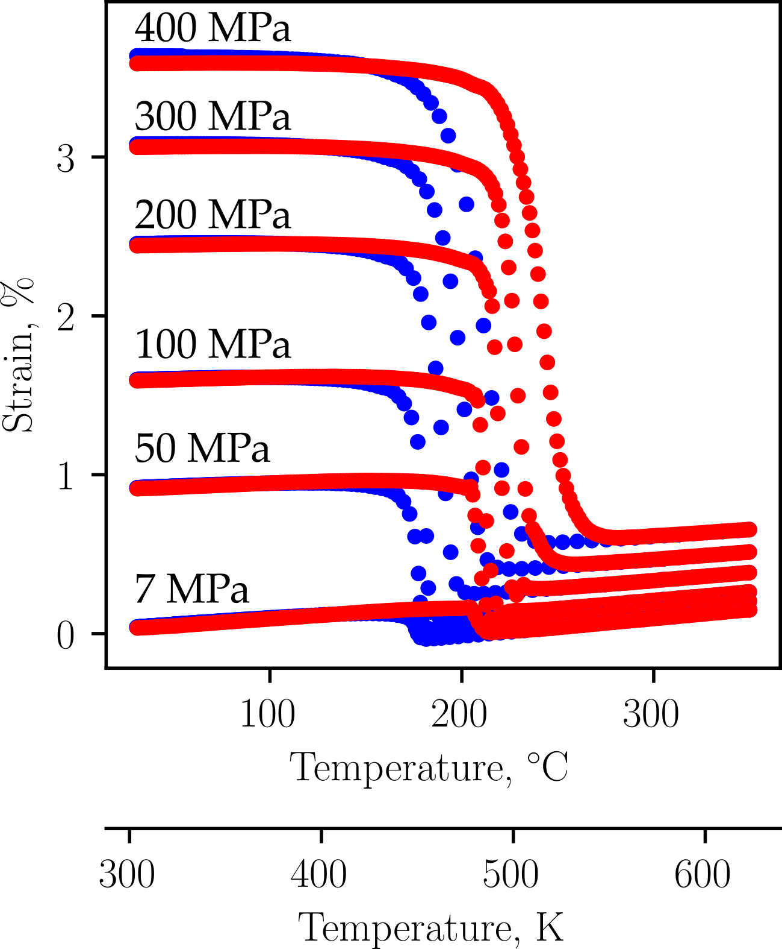

Figure : To demonstrate the utility of SMA-REACT, we will calibrate a constitutive model to fit published experimental data [28].

To calibrate an accurate SMA constitutive model to capture actuator behavior, *n* constant force thermal cycling tests are needed, where *n* is preferably greater than 4. Each test requires stress-strain-temperature histories. We use an experimental dataset for a Ni50.5Ti27.2Hf22.3 alloy from Bigelow et al [28]. The six different constant force cycles, non-zero coefficients of thermal expansion, and nonlinear relationship between applied stress and transformation strain make this data set a great calibration example. A starting point that identifies some educated guesses of select parameters are needed to enable REACT to perform a timely calibration via global optimization.

**Identifying Starting Points**

There are 17 unknown parameters that define the Lagoudas SMA constitutive model. Giving an educated guess to some of these parameters, (transformation temperatures, thermoelastic properties ) can result in a more accurate and timely model calibration.

|  |  |
| --- | --- |
| a) Constant-stress force cycling data for five distinct stress levels. | b) Zero-stress transformation temperatures and stress-influence coefficients at the calibration stress are extracted directly from CFTC data. |
| c) Austenite elastic modulus are found via Hooke's law at the reference temperature, which is a model parameter defined by the analyst. |  |

Figure 4 - Given constant-stress thermal cycling (CFTC) data for several stress levels, the Lagoudas SMA constitutive model can be calibrated using local curve-fitting routines. However, this method still relies on many manual iterations to find smooth hardening coefficients (not shown above). In each subfigure above, the parameters found are displayed in the grey box in the lower-right corner.

First, transformation temperatures for each tested stress level can be estimated via the tangent method or similar. If a “zero-stress” isobaric test (i.e., 7 MPa or lower) was performed, the transformation temperatures found for this test can be taken as the zero-stress transformation temperatures etc. Otherwise, each zero-stress transformation temperature can be found via the x-intercept of a linear regression of the transformation temperatures as a function of stress. This linear estimate is equivalent to a Lagoudas model calibration with smooth hardening parameters set to . The average slope of the start and finish transformation surfaces for martensite and austenite for a specified stress range about the user-determined *calibration stress* can be taken as the stress-influence coefficients ( and ). Note that the stress-influence coefficients should not be derived from the average slope from estimated transformation temperatures at all stress levels; most shape memory alloys exhibit a nonlinear change in transformation temperature with respect to stress (see Figure 3(b) in [28]), and the Lagoudas model compensates for this via the transformation surfaces (), where the stress-influence coefficients at the calibration stress are a contributing factor.

With transformation temperatures and stress-influence coefficients estimated, thermoelastic properties and transformation strain properties can be calculated. Austenite elastic modulus can be found by extracting the total strains and a temperature well above at each tested stress level. Then, by designating this temperature such that , Hooke’s law becomes:

Austenite elastic modulus is the best-fit linear coefficient from this equation.

The coefficient of thermal expansion can be calculated separately by extracting the total strain at another temperature :

AIf , the strain due to thermal expansion will be incorrectly predicted across the tested temperature range; however, this is a limitation of the one-dimensional reduction of the Lagoudas constitutive model.

Some material properties are estimated and can now act as bounds. For example, the estimated austenitic elastic modulus of 55 GPa can act as an upper and lower bound of 50 GPa to 80 GPa, respectively. This allows the optimizer to start in the neighborhood of feasible solutions, but gives it freedom to explore for a better performing result.To fully capture the true strain-temperature response, iterative calibration of each smooth hardening coefficient is necessary until a satisfactory fit is accomplished. Due to the interdependencies highlighted earlier, each change of smooth hardening coefficient will need to be accompanied by a change in the associated transformation temperature and perhaps stress-influence coefficient (i.e., a change in will need to be accompanied by a change in and ).

The global numerical calibration of REACT includes a preliminary genetic algorithm followed by a gradient-based algorithm. Then, based on the values to which the optimization converged, the parameters that converged to the bounds were further inspected, bounds were widened, further improving the calibration accuracy. This process of inspecting the converged results and comparing to the optimization bounds was repeated three times until each parameter converged to a value well within the set bounds. Thus, a local optimum is found. With a large enough initial population in the genetic algorithm, one can be confident that this is near the globally optimal calibration for this model formulation. One can see the improvements in iteration in Table 2.

Table : The SMA-REACT tool allows further refinement of the calibrated solution.

|  |  |  |
| --- | --- | --- |
| **Calibration Number** | **Mean squared error** | **Notes** |
| 1 | 3.13% | Educated guess, . |
| 2 | 2.09% | Numerical calibration with bounds around analytical values |
| 3 | 1.57% | Widened bounds on and . |
| 4 | 1.46% | Widened bounds on and . Fixed and . |
| 5 | 1.43% | Widened bounds on . Fixed everything but transformation temperatures and . |

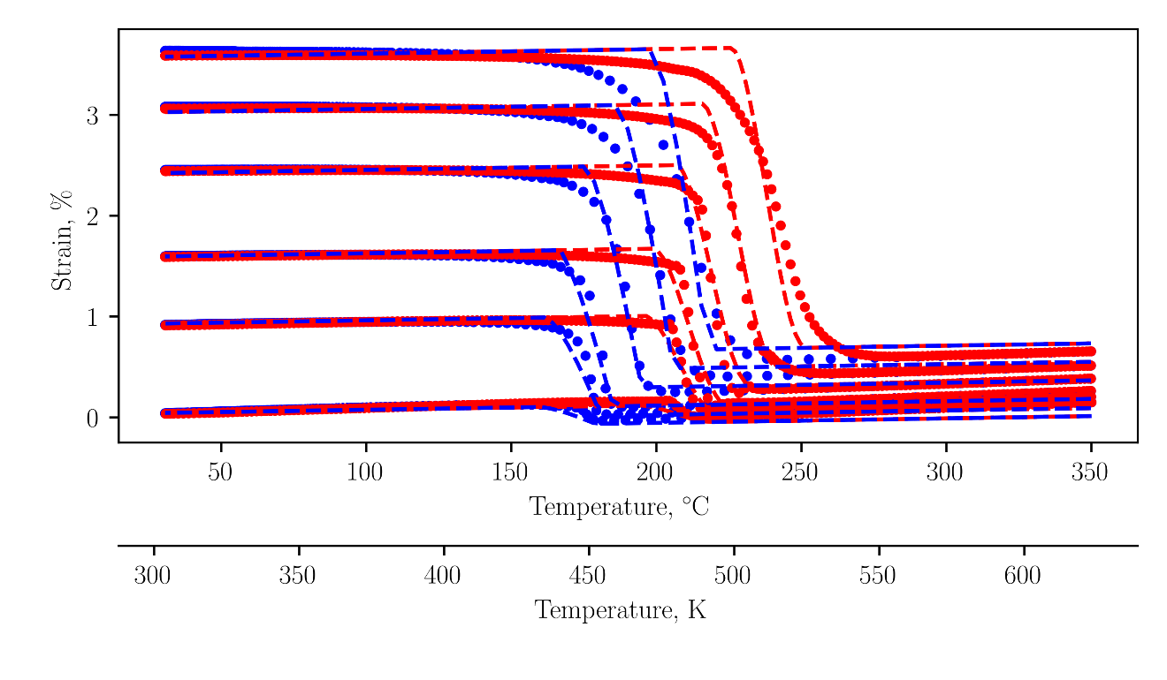

Figure : The final calibration agrees with the experimental data to within 1.5% mean squared error.

The final numerical calibration is depicted in Figure 5. The model predicts the elastic response in martensite accurately, which signifies that both the martensitic elastic modulus and transformation strain properties are well calibrated. Transformation temperatures show good agreement at low levels of applied stress. At higher levels of applied stress, the model-predicted transformation overshoots the experimental data and predicts a smaller hysteresis. This is because the transformation temperatures are not a linear function of stress (i.e., the stress-influence coefficients are not constant, see figure 3b in Bigelow [28]), and because the smoothness of transformation initiation is not constant with stress (compare the 100 MPa transformation into austenite with the analogous location at 300 MPa). This calibration is a great example of the utility of numerical optimization; the optimizer finds the best global fit of data, especially regarding the austenite transformation temperatures. For lower stresses, is too low, and is too high. At intermediate stresses, like 100 and 200 MPa, the transformation temperatures are almost perfect. Then, at 300 MPa, is too high and is too low. This could be better fit at the relevant stresses by biasing the solution to prioritize fitting certain stress levels (see [23]) or by simply calibrating the model at the stress levels that matter most.

However, this calibration is not perfect, mainly due to model deficiencies. In reality, the coefficient of thermal expansion is not constant for austenite and martensite. Clearly, the coefficient of thermal expansion in austenite is larger than that in martensite. This is a model deficiency because the current model uses a convex cutting plane assumption for numerical integration and could be improved in future work.

Regardless, these five optimizations improved calibration accuracy by over 50% compared to educated guesses , and were accomplished in less than an hour on a lightweight laptop with a low-performance processor (Intel Core m3-6Y30 CPU @ 0.90 GHz with 4 Gb RAM). This calibration routine can be performed by general analysts, designers, or material scientists, without the need for exotic hardware, python programming experience, or relatively clean datasets

**Conclusions and further refinements**

SMA-REACT is an open-source, easy-to-use tool for characterization data post-processing and shape memory alloy constitutive model calibration. While we have focused on the Lagoudas constitutive model and actuator (i.e., constant force thermal cycling) behavior, the tool is easily extensible to other constitutive models or loading modes. By framing the calibration routine as a numerical optimization problem, SMA-REACT can find robust calibrations that outperform conventional (i.e., by hand) calibrations by 50% or more, without requiring detailed knowledge of programming, optimization, or the Lagoudas constitutive model. This allows the tool to be approachable for a wide range of students and professionals working on shape memory alloys. The speed at which model calibrations can be fine-tuned allows for rapid iterations to converge to a satisfactory model calibration, which can then be used in commercial finite element suites like ABAQUS.

We distribute the SMA-REACT toolset and source code under the GNU General Public License, which allows anyone to run, study, share, and modify the code. We invite any modifications that users may find useful, including, but not limited to, alternative loading modes (i.e., superelasticity or combined superelasticity/shape memory [29]), alternative constitutive models [6], [30], [31], [32], or any usability enhancements for more robust data import or export. In particular, we believe integration with other open-source tools, such as the Shape Memory Materials Database and SMAnalytics would be very enabling to the greater SMA community [2]. SMA-REACT aims to reduce the barrier between materials scientists and engineers, and will hopefully enable more widespread adoption of shape memory alloys in engineering applications.

**Bibliography**

[1] J. M. Jani, M. Leary, A. Subic, and M. A. Gibson, “A review of shape memory alloy research, applications and opportunities,” *Mater. Des.*, vol. 56, pp. 1078–1113, 2014, doi: 10.1016/j.matdes.2013.11.084.

[2] O. Benafan, G. S. Bigelow, and A. W. Young, “Shape Memory Materials Database Tool—A Compendium of Functional Data for Shape Memory Materials,” *Adv. Eng. Mater.*, vol. 22, no. 7, p. 1901370, 2020, doi: 10.1002/adem.201901370.

[3] P. E. Caltagirone and O. Benafan, “Shape Memory Materials Analysis and Research Tool (SM2ART): Finding Data Anomalies and Trends,” *Shape Mem. Superelasticity*, Jul. 2023, doi: 10.1007/s40830-023-00457-7.

[4] M. Elahinia, M. Nematollahi, K. S. Baghbaderani, A. Nespoli, and F. Stortiero, “Chapter 6 - Manufacturing of shape memory alloys,” in *Shape Memory Alloy Engineering (Second Edition)*, A. Concilio, V. Antonucci, F. Auricchio, L. Lecce, and E. Sacco, Eds., Boston: Butterworth-Heinemann, 2021, pp. 165–193. doi: 10.1016/B978-0-12-819264-1.00006-6.

[5] D. Lagoudas, D. Hartl, Y. Chemisky, L. Machado, and P. Popov, “Constitutive Model for the Numerical Analysis of Phase Transformation in Polycrystalline Shape Memory Alloys,” *Int. J. Plast.*, vol. 32–33, pp. 155–183, 2012.

[6] L. C. Brinson, “One-Dimensional Constitutive Behavior of Shape Memory Alloys: Thermomechanical Derivation with Non-Constant Material Functions and Redefined Martensite Internal Variable,” *J. Intell. Mater. Syst. Struct.*, vol. 4, pp. 229–242, 1993.

[7] W. Trehern, R. Ortiz-Ayala, K. C. Atli, R. Arroyave, and I. Karaman, “Data-driven shape memory alloy discovery using Artificial Intelligence Materials Selection (AIMS) framework,” *Acta Mater.*, vol. 228, p. 117751, Apr. 2022, doi: 10.1016/j.actamat.2022.117751.

[8] A. Demblon, J. H. Mabe, and I. Karaman, “Compositional effects on strain-controlled actuation fatigue of NiTiHf high temperature shape memory alloys,” *Scr. Mater.*, vol. 242, p. 115904, Mar. 2024, doi: 10.1016/j.scriptamat.2023.115904.

[9] S. J. Honrao, O. Benafan, and J. W. Lawson, “Data-Driven Study of Shape Memory Behavior of Multi-Component Ni–Ti Alloys in Large Compositional and Processing Space,” *Shape Mem. Superelasticity*, vol. 9, no. 1, pp. 144–155, Mar. 2023, doi: 10.1007/s40830-022-00405-x.

[10] M. C. Kuner, A. A. Karakalas, and D. C. Lagoudas, “ASMADA—A tool for automatic analysis of shape memory alloy thermal cycling data under constant stress,” *Smart Mater. Struct.*, vol. 30, no. 12, p. 125003, 2021.

[11] ASTM, “Standard test method for mechanical uniaxial constant force thermal cycling of shape memory alloys,” ASTM International, West Conshohocken, PA, E3097-17, 2017. [Online]. Available: https://www.astm.org/e3097-17.html

[12] D. E. Nicholson *et al.*, “Standardization of Shape Memory Alloys from Material to Actuator,” *Shape Mem. Superelasticity*, vol. 9, no. 2, pp. 353–363, Jun. 2023, doi: 10.1007/s40830-023-00431-3.

[13] D. Hartl and D. C. Lagoudas, “Characterization and 3–D Modeling of Ni60Ti SMA for Actuation of a Variable Geometry Jet Engine Chevron,” in *Proceedings of SPIE, Smart Structures and Materials*, San Diego, CA, Mar. 2007, pp. 1–12.

[14] L. Xu, T. Baxevanis, and D. C. Lagoudas, “A three-dimensional constitutive model for the martensitic transformation in polycrystalline shape memory alloys under large deformation,” *Smart Mater. Struct.*, vol. 28, no. 7, p. 074004, Jun. 2019, doi: 10.1088/1361-665X/ab1acb.

[15] L. Xu, A. Solomou, T. Baxevanis, and D. Lagoudas, “Finite strain constitutive modeling for shape memory alloys considering transformation-induced plasticity and two-way shape memory effect,” *Int. J. Solids Struct.*, vol. 221, pp. 42–59, Jun. 2021, doi: 10.1016/j.ijsolstr.2020.03.009.

[16] G. Scalet, F. Niccoli, C. Garion, P. Chiggiato, C. Maletta, and F. Auricchio, “A three-dimensional phenomenological model for shape memory alloys including two-way shape memory effect and plasticity,” *Mech. Mater.*, vol. 136, p. 103085, Sep. 2019, doi: 10.1016/j.mechmat.2019.103085.

[17] F. Auricchio, A. Coda, A. Reali, and M. Urbano, “SMA Numerical Modeling Versus Experimental Results: Parameter Identification and Model Prediction Capabilities,” *J. Mater. Eng. Perform.*, vol. 18, no. 5, pp. 649–654, Aug. 2009, doi: 10.1007/s11665-009-9409-7.

[18] D. J. Hartl and D. C. Lagoudas, “Thermomechanical Characterization of Shape Memory Alloy Materials,” in *Shape Memory Alloys: Modeling and Engineering Applications*, D. C. Lagoudas, Ed., New York: Springer-Verlag, 2008.

[19] D. Whitten and D. Hartl, “Iterative calibration of a shape memory alloy constitutive model from 1D and 2D data using optimization methods,” in *Behavior and Mechanics of Multifunctional Materials and Composites 2014*, SPIE, 2014, pp. 21–31.

[20] *Material Calibration - 3DExperience*. (Oct. 08, 2024). Dassault Systemes, Woodlands Hills, CA. Accessed: Oct. 08, 2024. [Online]. Available: https://help.3ds.com/2024x/English/DSDoc/MatCalibUserMap/matcalib-c-ov.htm?contextscope=cloud&id=27e963e7360f4cddb5af8a8c7ab38e45&_gl=1*rhnu28*_up*MQ..*_ga*MTI1NDEzMTAyLjE3MjgzOTc0NTE.*_ga_DYJDKXYEZ4*MTcyODM5NzQ1MS4xLjAuMTcyODM5NzQ1MS4wLjAuMA..*_ga_39DKQ0LYW1*MTcyODM5NzQ1MS4xLjEuMTcyODM5NzQ1MS4wLjAuMA..

[21] P. B. C. Leal and M. A. Savi, “Shape memory alloy-based mechanism for aeronautical application: Theory, optimization and experiment,” *Aerosp. Sci. Technol.*, vol. 76, pp. 155–163, May 2018, doi: 10.1016/j.ast.2018.02.010.

[22] P. Walgren *et al.*, “Development and Testing of a Shape Memory Alloy-Driven Composite Morphing Radiator,” *Shape Mem. Superelasticity*, pp. 1–10, Jan. 2018, doi: 10.1007/s40830-018-0147-2.

[23] P. Walgren, S. Nevin, and D. Hartl, “Design, experimental demonstration, and validation of a composite morphing space radiator,” *J. Compos. Mater.*, p. 00219983221144499, Dec. 2022, doi: 10.1177/00219983221144499.

[24] K. Deb, A. Pratap, S. Agarwal, and T. Meyarivan, “A fast and elitist multiobjective genetic algorithm: NSGA-II,” *IEEE Trans. Evol. Comput.*, vol. 6, no. 2, pp. 182–197, 2002.

[25] F.-A. Fortin, F.-M. D. Rainville, M.-A. Gardner, M. Parizeau, and C. Gagné, “DEAP: Evolutionary Algorithms Made Easy,” *J. Mach. Learn. Res.*, vol. 13, pp. 2171–2175, Jul. 2012.

[26] P. Virtanen *et al.*, “SciPy 1.0: fundamental algorithms for scientific computing in Python,” *Nat. Methods*, vol. 17, no. 3, pp. 261–272, Mar. 2020, doi: 10.1038/s41592-019-0686-2.

[27] J. C. Simo and T. J. R. Hughes, “Integration Algorithms for Plasticity and Viscoplasticity,” in *Computational Inelasticity*, in Interdisciplinary Applied Mathematics. , New York, NY: Springer, 1998, pp. 113–153. doi: 10.1007/0-387-22763-6_3.

[28] G. S. Bigelow, A. Garg, O. Benafan, R. D. Noebe, S. A. Padula, and D. J. Gaydosh, “Development and testing of a Ni50.5Ti27.2Hf22.3 high temperature shape memory alloy,” *Materialia*, vol. 21, p. 101297, Mar. 2022, doi: 10.1016/j.mtla.2021.101297.

[29] P. B. C. Leal, M. Cabral-Seanez, V. B. Baliga, D. L. Altshuler, and D. J. Hartl, “Phase transformation-driven artificial muscle mimics the multifunctionality of avian wing muscle,” *J. R. Soc. Interface*, vol. 18, no. 184, p. 20201042, Nov. 2021, doi: 10.1098/rsif.2020.1042.

[30] L. C. Brinson and M. S. Huang, “Simplifications and Comparisons of Shape Memory Alloy Constitutive Models,” *J. Intell. Mater. Syst. Struct.*, vol. 7, pp. 108–114, 1996.

[31] F. Auricchio, R. L. Taylor, and J. Lubliner, “Shape-Memory Alloys: Macromodelling and Numerical Simulations of the Superelastic Behavior,” *Comput. Methods Appl. Mech. Eng.*, vol. 146, pp. 281–312, 1997.

[32] F. Auricchio and E. Sacco, “A One-Dimensional Model for Superleastic Shape-Memory Alloys With Different Elastic Properties Between Austenite and Martensite,” *Int. J. Non-Linear Mech.*, vol. 32, no. 6, pp. 1101–1114, 1997.

1. The calibration stress is *a priori* defined by the designer. Common practice dictates selecting a value close to the design working stress of the material.